1-Page Summary Report: Carly’s Clippers

Problem Statement
Carly’s Clippers needs clear operational metrics from last week’s sales so the owner can set prices, design promotions, and plan staffing for the rest of the month. Three parallel lists were provided (hairstyles, prices, units sold). Key questions: What is the average haircut price? How much revenue was earned? Which styles can be advertised under $30 after a planned $5 price reduction?

Solution Strategy
- Sum all prices and divide by the number of styles to obtain average price.
- Apply a uniform $5 discount via list comprehension → new_prices; identify styles still under $30.
- Compute total weekly revenue as Σ (price × units) and convert to average daily revenue (/7).
- Extend analysis with most-popular and highest-revenue styles, then run a short sensitivity simulation on discount size and sales volume.
- Present results with simple bar charts tailored to a busy owner (high subject knowledge, limited time, moderate data literacy).

Solution
Core results (original data):
- Average Haircut Price: $31.875 (before discount)
- New prices after −$5: [25, 20, 35, 15, 15, 30, 45, 30]
- Total Revenue last week: $1,085 → Average Daily Revenue: $155.00
- Cuts under $30 (advertisable): bouffant, pixie, crew, bowl (50 % of menu)
- Most popular style: crew (8 sales). Highest-revenue style: mohawk ($300, ~28 % of weekly revenue).
- 4-week projection at original prices: $4,340; at discounted prices (same volume): $3,660. Cost of the $5 discount: $680.
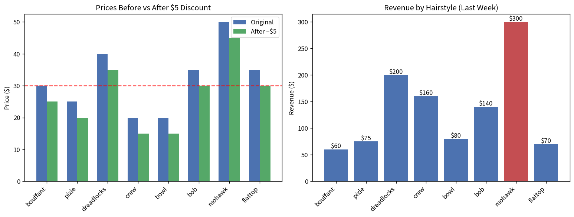
Figure: Original vs discounted prices (left) and revenue contribution by style (right; mohawk highlighted).

Key Takeaways
- Lead with the business numbers Carly needs: average price, weekly/daily revenue, and the short list of under-$30 styles she can advertise immediately.
- Protect the high-margin mohawk; use the high-volume crew cut carefully when designing promotions so margin is not eroded.
- A uniform $5 discount costs ~$680 over four weeks if volume stays flat. Test a smaller discount or selective discounting on mid-tier styles first.
- Audience fit: owner receives a one-page headline + chart + recommendation; the companion notebooks contain loops, list comprehensions, alternate zip/dict solutions, and a live simulation cell for the analyst or technical reviewer.
- Next experiment: advertise the four under-$30 cuts for two weeks and measure visit lift; the simulation cell already supports changing discount size and sales multiplier.

